**Looker POC & Power BI – Project Requirement**

**Project Title:** Development of a Clinical Performance Dashboard in Looker

**Objective:** To create a comprehensive and interactive dashboard in Looker for visualizing and analyzing clinical performance metrics by department.

**Key Features:**

1. **Dashboard Interface:**
   * A prompt that allows users to select a specific Department by name.
   * A prompt that allows users to select a Month.
   * A clear and intuitive interface to enhance user experience.
   * A header with the title 'Clinical Performance Dashboard'.
   * Subheaders for 'Month' and 'Department' selection filters.
2. **Data Visualization:**
   * A structured layout that displays the performance of different departments in the hospital based on various Key Performance Indicators (KPIs).

**KPIs and Metrics:**

* + The dashboard will showcase a breakdown of departmental performance based on the following KPIs:

| **KPI** | **Description** |
| --- | --- |
| Hospitalization Rate | Measures the rate of hospitalizations. |
| Hospitalization PPPY Rate | Hospitalization rate per person per year. |
| Treatment Charge | Costs associated with treatments. |
| Readmissions Rate | Rate of patients readmitted after initial discharge. |
| Immunization Rate | Percentage of patients receiving required immunizations. |
| Mortality Rate | The rate of mortality within the department. |
| Follow-up Rate | Frequency of follow-ups post-treatment. |
| Final Operating Score | An average score based on all the above metrics. |

**Visualization Columns:**

| **Order** | **Column Name** | **Description** |
| --- | --- | --- |
| 1 | Clinical Measure Name | Name of the clinical measure being evaluated. |
| 2 | Current Month Metric Rate | The rate of the metric for the current month. |
| 3 | Trend Indicator | A green arrow for improvement, or a red arrow for decline in the metric rate. |
| 4 | Metric Rate Calculation | Calculated as Metric Rate Numerator Value / Metric Rate Denominator Value. Denominator is Total Patients. |
| 5 | Points Earned | Points earned for each metric rate. |
| 6 | 13-Month Trend | A sparkline chart showing the last 13 months' metric rate trend. |

1. **Backend Data Structure:**
   * The dashboard will be powered by a monthly summary table with the following columns:

| Column Name | Description / Sample Value |
| --- | --- |
| Period Month | Date of the record (e.g., 01012024) |
| Department ID | Unique identifier for the department (e.g., 1001) |
| Department Name | Name of the department (e.g., Aurora) |
| Metric ID | Identifier for the metric (e.g., 1) |
| Metric Name | Name of the metric (e.g., Mortality Rate) |
| Metric Numerator Value | Numerator value for the metric calculation (e.g., 15) |
| Metric Denominator Value | Denominator value for the metric calculation, representing Total Patients (e.g., 150) |
| Points Earned | Points earned based on the metric (e.g., 22) |

**DataSource :**



**Screen Mockup**

* The dashboard design should follow the layout and style of the provided mockup image, focusing on simplicity and readability.
* A minimalist blue and white color scheme should be used, consistent with the professional medical aesthetic of the mockup.

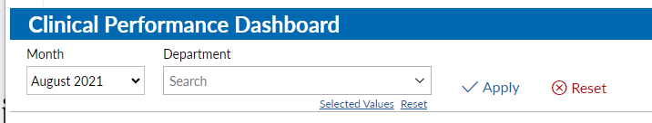

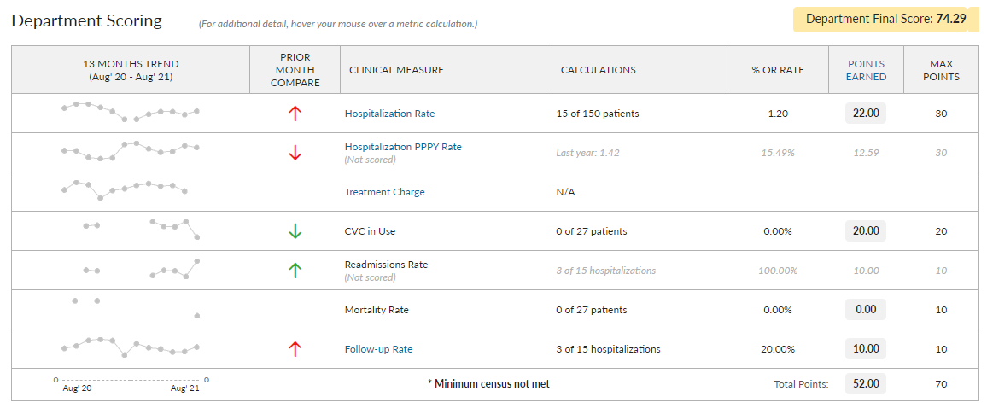

Other Requirements

|  |  |  |
| --- | --- | --- |
| **#** | **Details** | **Status** |
| 1 | Use Value and Display Value for Filter dropdown should be different example for Dpeartment Use Value that is filter by column should be department_id and display value should be Department Name |  |
| 2 | 13 Month Trending Column |  |

**\*\* Visualization 2 of the Dashboard Requirements**

1. **Data Preparation and Backend Structure Development**:
   * Develop mockup data and backend structures that are necessary to support the new Visualization 2.
2. **Dashboard Layout Enhancement**:
   * Position Visualization 2 to the right of Visualization 1 on the same dashboard, ensuring a cohesive and user-friendly layout.
3. **Bar Graph Feature**:
   * Implement a bar graph within Visualization 2. This graph should display the count of hospitalized patients, categorized by the reason for hospitalization.
   * The data represented should be filterable by both the selected month and department.
4. **Interactive Data Exploration**:
   * Introduce an interactive feature where clicking on a specific bar in the graph triggers a pop-up window.
   * This pop-up window will display a table detailing the top 10 sub-reasons for hospitalization, along with the corresponding patient count, relevant to the selected reason from the bar graph.

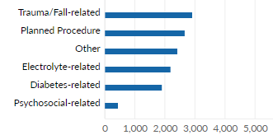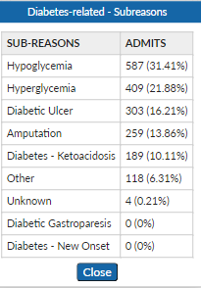

Paginated Report Requirement

**Technical Requirements for Building the 'Paginated Report by Product Line'**

1. **Data Organization and Structure**:
   * The report must support multiple product lines, with each product line being displayed on a separate page.
   * For each product line, the report should categorize data by product type.
2. **Data Fields**:
   * The report should display the following fields for each product type: quantity sold, actual revenue, and planned revenue.
3. **Report Design and Layout**:
   * Each page must clearly state the product line being analyzed at the top.
   * Data should be presented in a table format for clarity and easy comparison.
4. **Data Source and Integration**:
   * Ensure the report can pull data from the designated source(s) accurately.
   * The data should be dynamically updated to reflect the current sales figures.
5. **Pagination and Navigation**:
   * Implement pagination to handle multiple product lines efficiently.
   * Include navigation controls for users to easily move between different product line pages.
6. **Report Generation and Export Capabilities**:
   * The system should be capable of generating the report on-demand.
   * Provide options to export the report in PDF format for distribution and offline access.

Sample Output



Sample Data

